|  |  |
| --- | --- |
|  |  |
| Agricultural forum (PROJECT PROPOSAL) |  |
|  |  |
|  |  |

Thushan Dewinda-858

Bathiya Lakruwn-883

Randunu Bandara-806

Anuradha Kandewaththa-1090

ABSTRACT

Cultivation is an important sector in Sri Lanka. In cultivation, lot of parties are involved in it. Such as Agricultural department, weather department, Water suppliers, third party, sellers, buyers, transport services, fertilizer weed killer and insecticide making companies, labors etc. with enrolment of these parties ,get the results of severe price fluctuations ,high post-harvest losses and high cost of business activities and finally low income for the farmer. It is very unfair for the farmer. we should minimize contribution of third party for this process. Within this application we will be able to find solution for this problem.

This application is mostly suitable for Farmers, Sellers, Buyers, Transport services owners, Drivers, Brokers. All the users are group by districts. One user can create only one account with same user name. But user can perform one or more characters on their accounts. Ex: Same user can perform as Farmer and Transporter.

In this project we able to give some features given below;

* Users can log in to their account and change or update details.

Ex:

Farmer can update details about his available crops and prices. Agricultural consultative can upload Articles, videos, e books to their accounts. Buyers can add details about their daily purchase prices. Transport Service owners can add their locations and prices.

* Farmers can easily describe their problems to the agricultural consultative through the conversations.
* If any user would like to give their current location details, any of other user can find him through the app. Ex: Seller can find farmer and after buying crops find nearest transport service to deliver crops to the market.

In future when developing this app, we expect to provide new features such as;

* E banking service for users.
* Participations of governmental sectors such as; Agricultural department, weather department, water board, geological research department etc.
* Insecticides, weedicides and fertilizer companies can join with this app for publish their advertisements.

All of these facilities we expect to give a practical solution for the minimize the affliction and loss of farmers and sellers when selling crops.

Contents

* Team Members and the role
* What to Expect
* Research and Outreach
* Requirements
* Framework
* Development
* Testing and Launch
* Project Milestones
* Scope Details
* Project Cost
* Gantt chart
* Risk management
* WBS

## **Team Members and the role**

* Thushan dewinda 858 - Managing the database, Developing the application
* Bathiya Lakruwn 883 -Developing the application, Writing the reports, designing UI
* Anuradha Kandewaththa 1090 -Writing the reports, Developing the application
* Randunu Bandara 806 -Designing the graphics, Managing the database

## **What to Expect**

* A main objective of this project is to help farmers to sell their products to the market easily without a third party.
* This is a computerized approach to maintain a better and clear market.
* Farmers and the shoo owners can know the current rates of market.

**Research and outreach**

* The old way like searching for this program we start to talking farmers, sellers & vegetable shop owners.
* And also, we talk some other parties, such as framers, transporters, Agricultural consultative, Dealers, Shop owners
* We gather their ideas and information to develop our idea.

**SYSTEM REQUIREMENTS**

**NON-FUNCTIONAL REQUIREMENTS**

EFFICIENCY REQUIREMENT

When this system was developed, user can simply access the system and user can easily do their works

RELIABILITY REQUIREMENT

The system ought to accurately perform member registration, member validation, data input, data delete, and search

USABILITY REQUIREMENT

The system is intended for a user-friendly setting so users will perform the assorted tasks simply and in a good method. structure demand.

**FUNCTIONAL REQUIREMENTS**

1. NORMAL USER

* 1. USER LOGIN

**Description of feature**

It required to enter user id and password before they are allowed to enter the system. The user id and password will be verified and if invalid ID is there user is allowed to not enter the system.

**Functional requirements**

* user id is provided when they register
* The system must only allow user with valid id and password to enter the system
* The user must be able to logout after they finished using system

.

* 1. REGISTER NEW USER

**Description of feature**

It can be performed by all users to register new user to create account.

**Functional requirements**

* System must be able to verify information.
* System must be able to delete information if information is wrong.
* System must be able to not allow users having same user id.
* User must choose his area.
  1. REGISTER NEW PRODUCT

**Description of feature**

It allows to add new product in to system.

**Functional requirements**

* System must be able to verify information.
* System must be able to not allow product having same product id.
  1. SEARCH PRODUCT, USERS

**DESCRIPTION OF FEATURE**

User can search users, Product based on users id, Product id, users name, Product name, area.

**Functional requirements**

* System must be able to search the database based on select search type
* System must be able to filter based on keyword entered

## **Development**

## **Testing and launch**

**Project Milestones**

|  |  |  |
| --- | --- | --- |
| Name | Target Date | Comments |
| Project Kick off |  |  |
| Milestone 2 |  |  |
| Milestone 3 |  |  |
| Completion |  |  |

# Table 1

# Scope Details

|  |  |
| --- | --- |
| In scope | Out of scope |
| Farmers will able to Share their information through the application | Connections between farmers and weather department. |
| Facility of getting all the updates of daily market prices and other details. | Participation of Insecticides, weedicides and fertilizer companies. |
| Any of user will able to find the location of their nearby transport agent through the application. | E banking feature for all users. |
| Agricultural consultative can update their accounts with information about agriculture. |  |
| Farmers can discuss their problems with consultative through the application. |  |
|  |  |

# Table 2

|  |  |  |  |
| --- | --- | --- | --- |
| Project Expense | Cost Center | Comments | Est. Amount |
|  |  |  |  |
|  |  |  |  |
|  |  |  |  |
|  |  |  |  |
|  |  |  |  |
|  |  |  |  |
|  |  |  |  |
|  |  |  |  |
|  |  |  |  |
|  |  |  |  |
|  |  |  |  |
|  |  |  |  |
|  |  |  |  |

# Project Costs

Table 3

Gantt chart

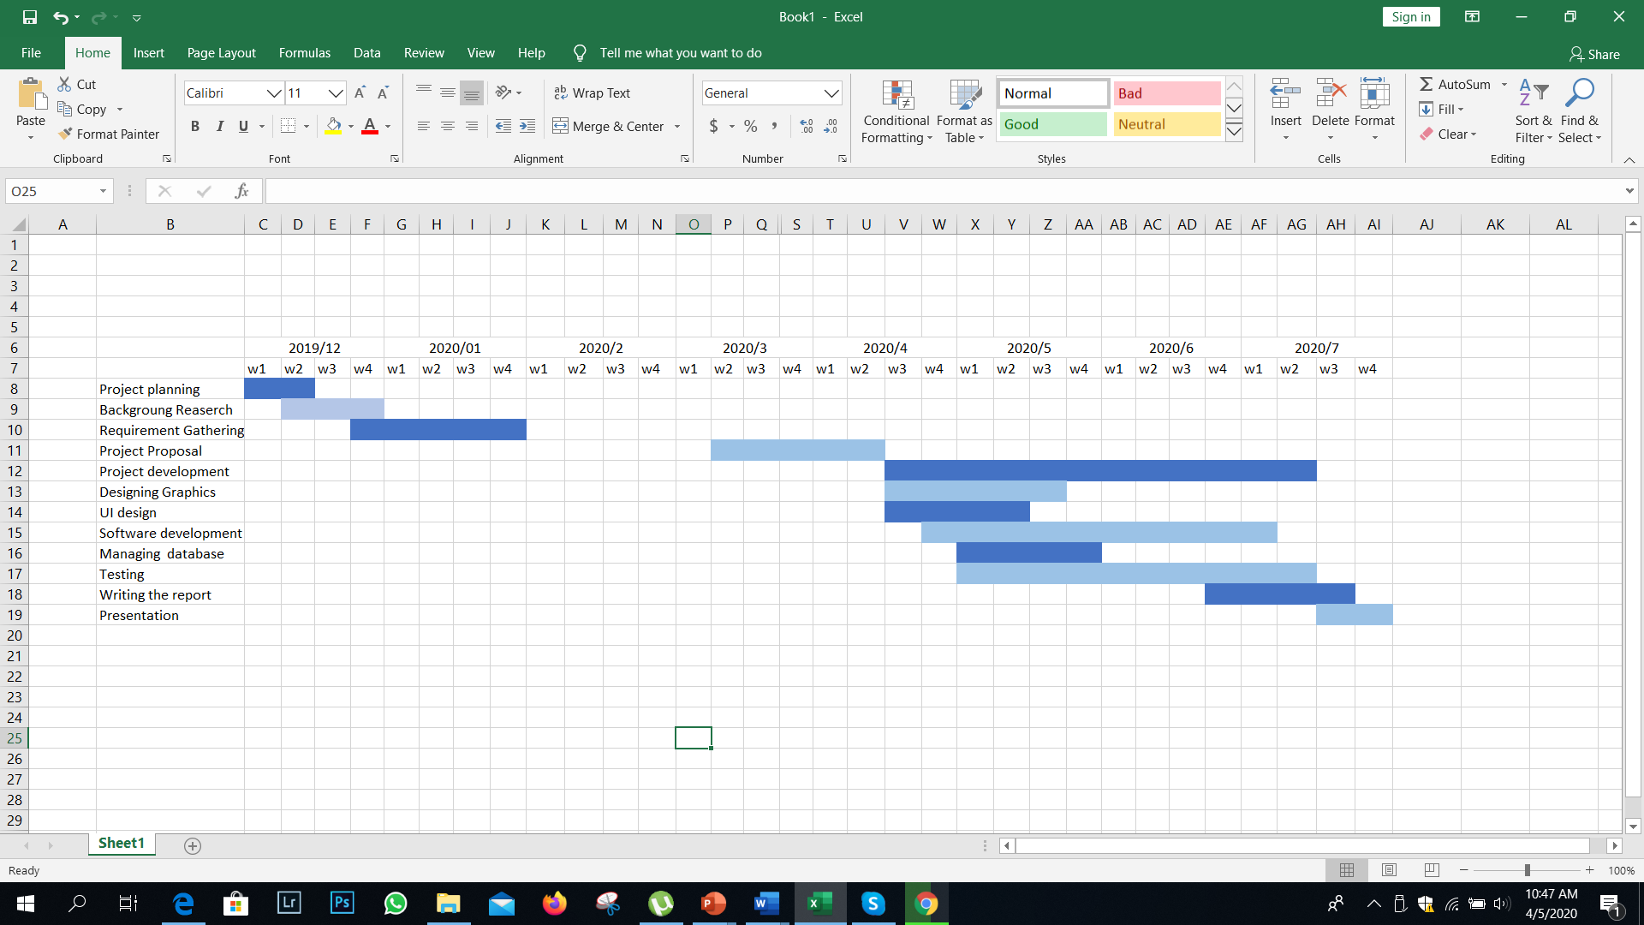

Graph 1

**Risk management**

**Possible Risks**.

|  |  |
| --- | --- |
| Risk | How to overcome |
| Technical Risks. (high risk)   * As this is the first working application we are developing, we have no experiences of doing programming. | * we have to learn a new programming language. |
| Resource Risk (high risk)   * As we are not in the campus, we are unable to talk with our lectures as well as use the library. | * We can use an online platform to talk with our lectures and we can use internet to find solutions for our problems. |
| Estimating time. (middle risk)   * It is not always possible to come up with the project with exact estimation. | * Doing the project according to the Gantt chart. |
| Quality Risk. (low risk)   * Risk related to the quality of the product. | We can do our project with the best quality that we can do. |
|  |  |

WBS

Database

Interfaces

Graphics

UI/UX design

Requirement

gathering

Testing

Software

Development

Design and

Analysis

Agricultural Forum (Project)